**Data:**

A 2018 report, Point-In-Time Count of the Homeless in the New Jersey, conducted by Monarch Housing Associates lists the number of homeless people per county, and per town in the State. The towns with high concentration of homeless people are typically saddled with demographics that are below poverty line and struggling to their day to day living. There is a report for state wide level summarizing the homeless count for each county in the state as well as reports for each county in the state – listing the homeless count for each municipalities for each county. .port can be accessed in the wed as a pdf file. done per county . The report for each county will be used to selectively identify municipalities/communities where a food bank may be established.

An example of the report is, note the report is in PDF so report needs to be scrapped in Python:

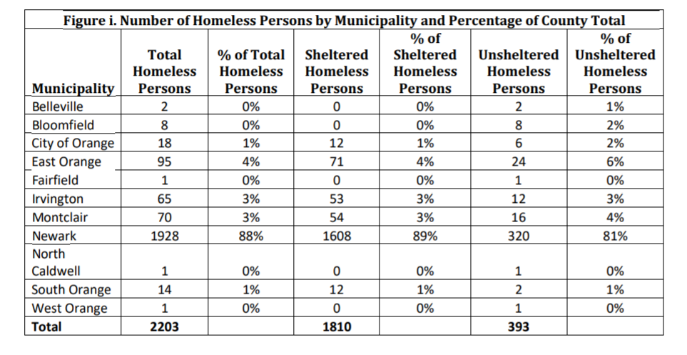

The State of New Jersey - GIS Open Data has an API where you can download a JSON file. The file has the geographical coordinates, among other things, of each municipalities. The API link is: https://maps.nj.gov/arcgis/rest/services/Framework/Government_Boundaries/MapServer/2/query?outFields=*&where=1%3D1

Foursquare API gives a list of restaurant per neighborhood/location. Using data from the report, we can selectively identify restaurant that can potentially contribute to the food banks. The list will be clustered into groups so that collection efforts will be maximized and will also determine the number of food banks to be established.

The UMCGNJ divided their presence in New Jersey into nine districts, the website list all the UMCGNJ churches , the town and district where they belong. This data can be downloaded from their website in XLS formal. This data can be used to determine where food banks can be established, i.e., what churches will run them. <https://www.gnjumc.org/districts/>, an screen shot of the xls file is shown below:

|  |  |  |  |
| --- | --- | --- | --- |
| **TOWN** | **CHURCH NAME** | **CHURCH NUMBER** | **DISTRICT** |
| DEPTFORD TWP | Almonesson UMC | 1001 | Gateway South |
| AUDUBON | Audubon UMC | 1002 | Gateway South |
| MANTUA TWP | Barnsboro UMC | 1003 | Gateway South |
| MANTUA TWP | Mt Zion UMC (Barnsboro) | 1004 | Gateway South |
| BARRINGTON | First UMC (Barrington) | 1005 | Gateway South |